**Connecting to MS SQL Server using DBeaver**

1. Go to <https://dbeaver.io/download/> and download the **dbeaver-ce-5.3.5-x86_64-setup.exe** file

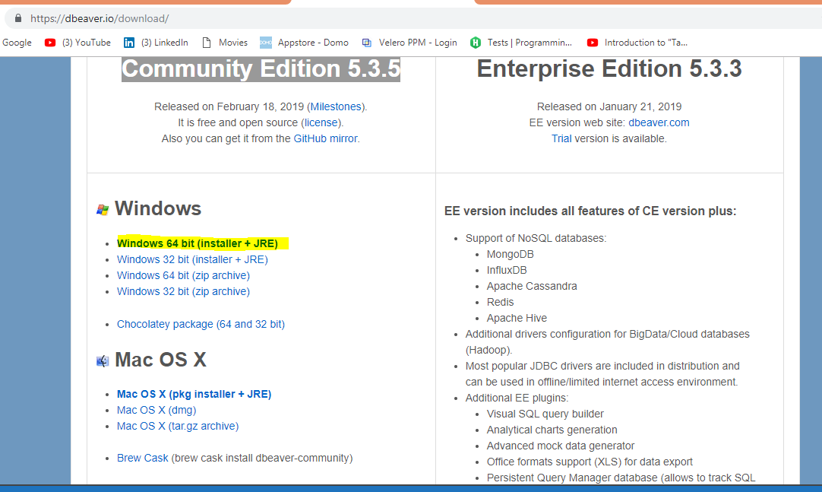

1. Run the file and follow the below steps in the screenshots for installation: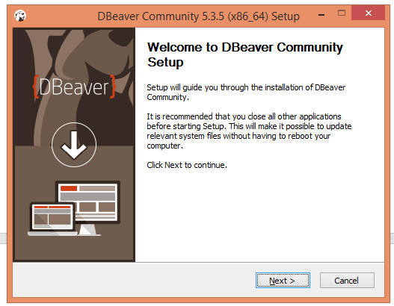

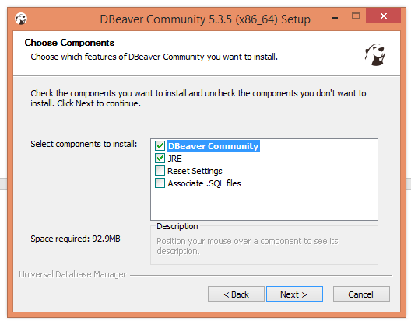

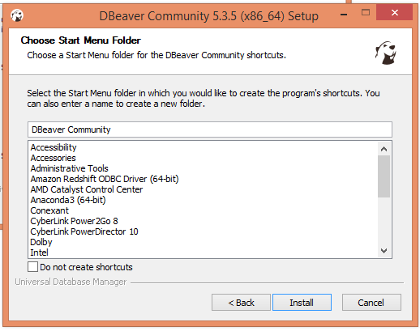

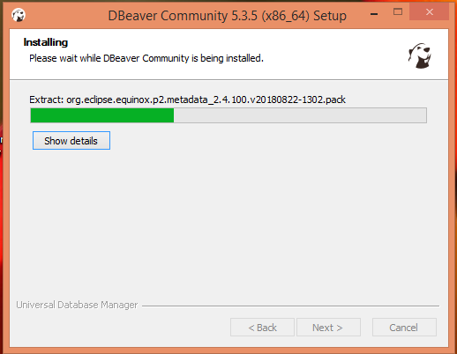

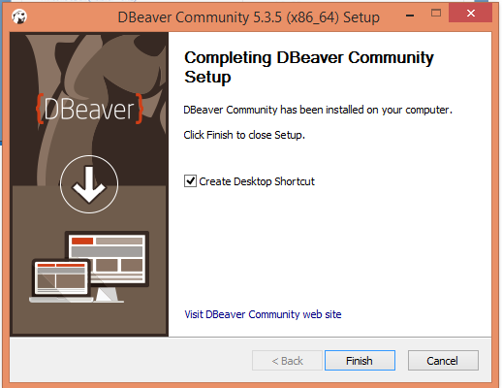

1. Open **DBeaver**

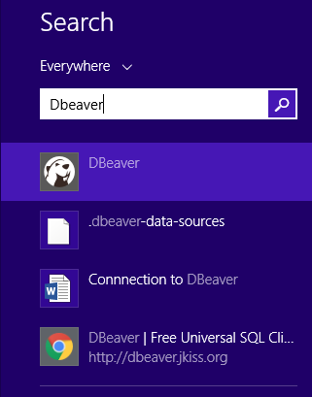

1. Go to **Database** and click on **New Database Connection**

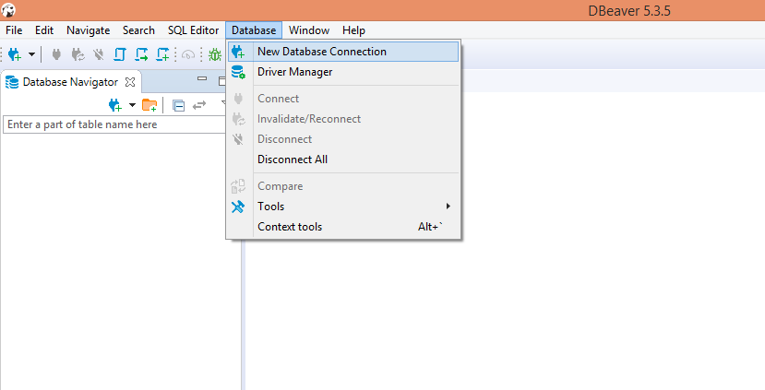

1. Select **Microsoft SQL server** and click on **Next**

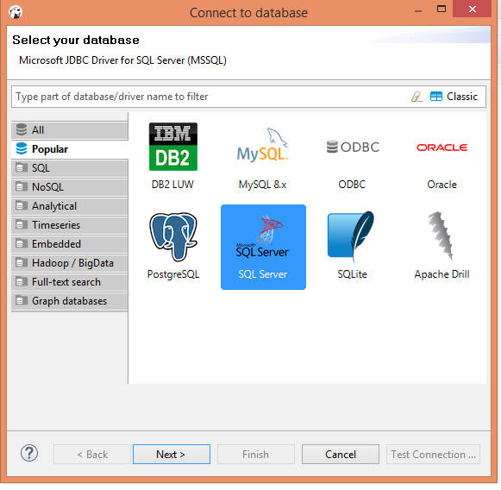

1. Enter the Host, credentials and click on Test connection to check if the server is getting connected successfully. Click on Finish.

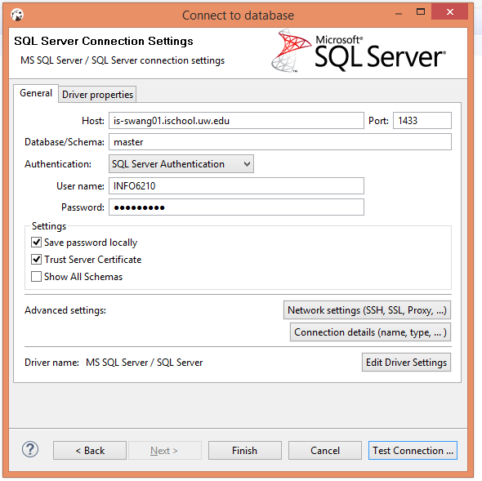

1. **Once your connected, you can see the databases and write SQL queries to extract the data from the different tables**

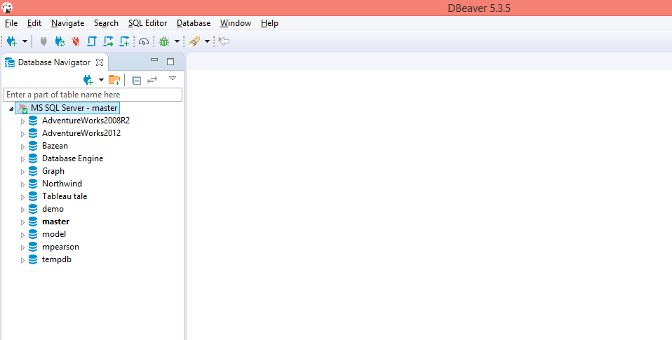

1. **Go to SQL Editor and click on new SQL Editor**

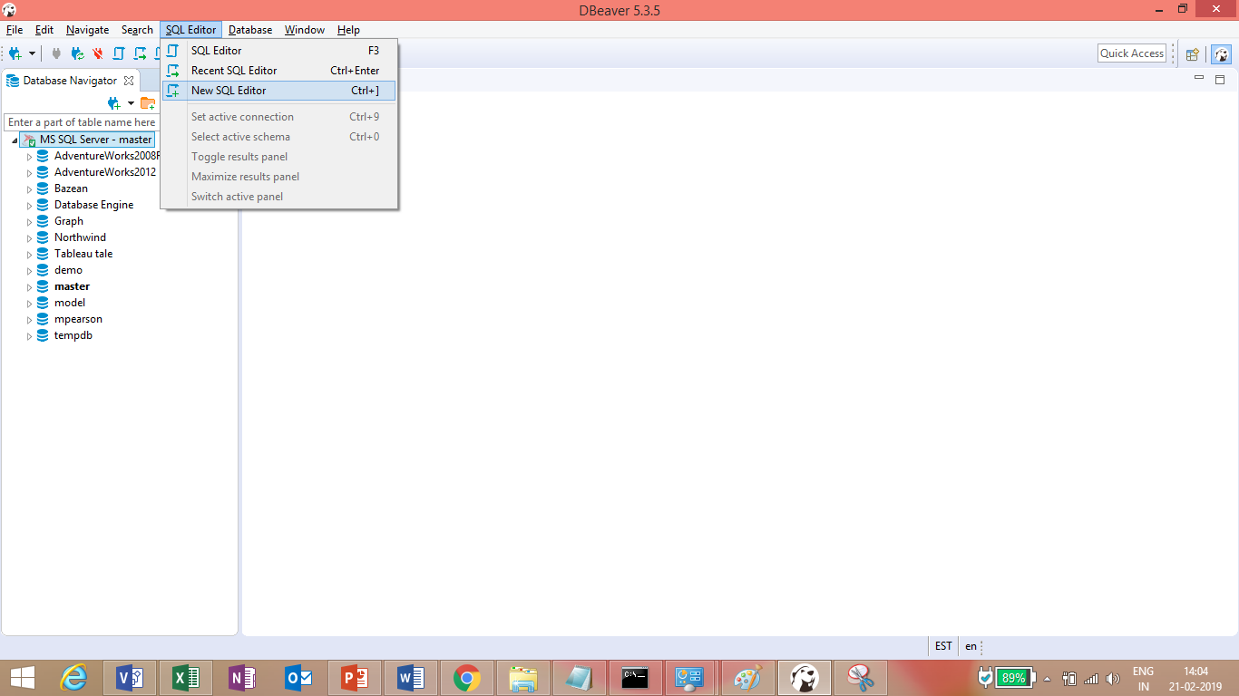

1. Sample Query using Database AdventureWorks2008R2

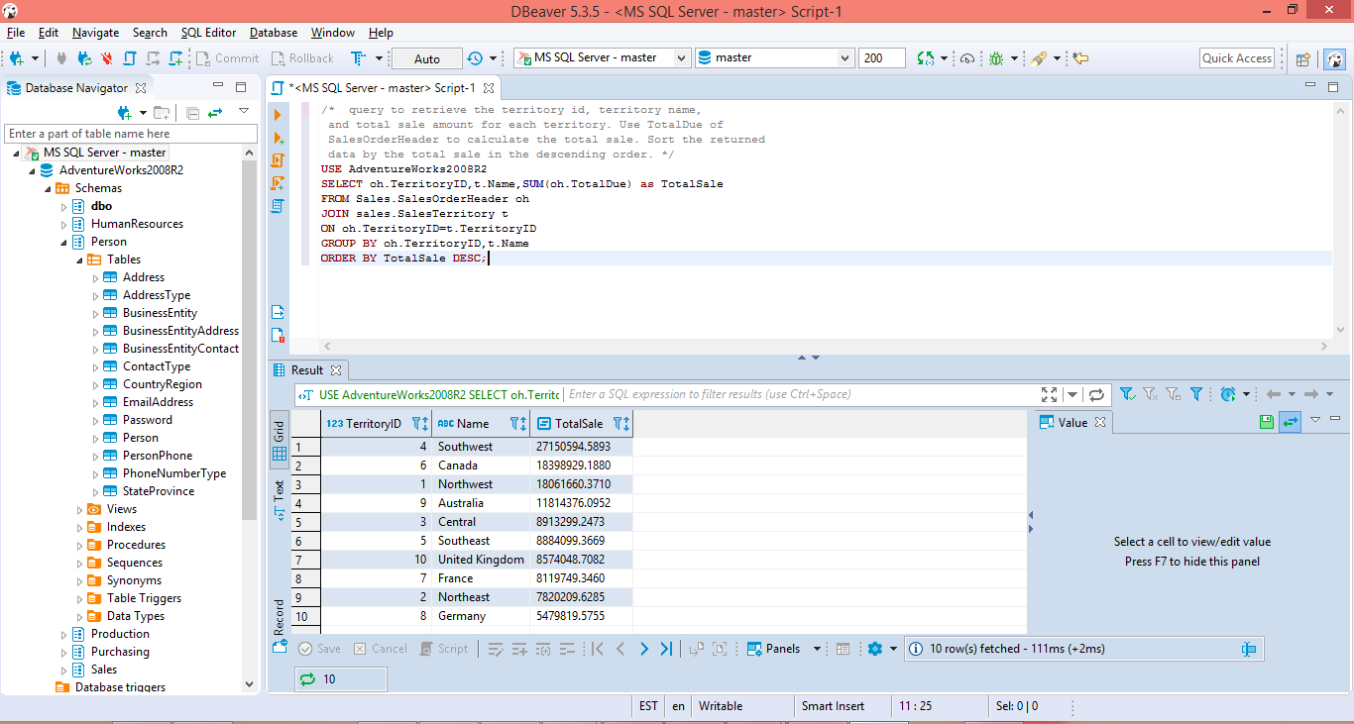

After writing the query, select everything and click on Orange Colour triangle shaped button:

**USE** AdventureWorks2008R2

**SELECT** oh.TerritoryID,t.Name,**SUM**(oh.TotalDue) **as** TotalSale

**FROM** Sales.SalesOrderHeader oh

**JOIN** sales.SalesTerritory t

**ON** oh.TerritoryID=t.TerritoryID

**GROUP** **BY** oh.TerritoryID,t.Name

**ORDER** **BY** TotalSale **DESC**;

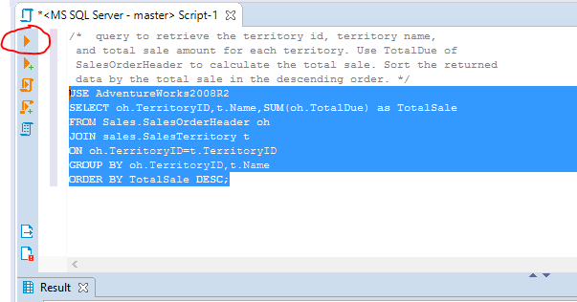

1. Using AdventureWorks2008R2 database, you can practice SQL by writing different queries and also can create your own database/ tables.